Egyptian E-Learning University
Faculty of Computers & Information Technology
OLMEG CONNECT
Smart Marketplace Platform Using Flutter & Firebase
Supervised by
DR. ASMAA HEKAL
Assistant Eng. MOHAMED SAIED
[ALEX] - 2026
By
Name: Youssef Hafez El Morsy ID 2200028
Name: Merna Mohamed Naeim ID 2201804
Name: Mina Hany Samir ID 2202185
Name: Youssef Abdelmonem Aly ID 2201393
Name: Rayan Ahmed ID 2201792
Name: Abdelrahman Anwar ID 2101962
Name: Mahmoud Haroun ID 2100914
Name: Ehab Ibrahim ID 2100611
Name: Adham Ahmed Hamdy ID 2100309
Name: tarek Mohamed abd elhakim ID 2101660

Acknowledgments
We would like to express our sincere appreciation to Dr. Asmaa Hekal for her continuous guidance, supervision, and valuable feedback throughout all stages of this project. Her support helped improve the project idea, documentation structure, and final presentation.
We also extend our thanks to Eng. Mohamed Saied for his technical assistance and helpful recommendations during the development and documentation phases. Special thanks go to the Faculty of Computers & Information Technology at the Egyptian E-Learning University for providing the academic environment and resources that supported the completion of this project.
We appreciate all team members who contributed to design, development, testing, debugging, documentation, screenshots, and project demonstration.

Contents
Abstract
Chapter 1 - Introduction
Chapter 2 - Literature Review / Related Work
Chapter 3 - Proposed System
Chapter 4 - Implementation
Chapter 5 - Testing & Evaluation
Chapter 6 - Results & Discussion
Chapter 7 - Conclusion & Future Work
References
Appendix A - Application Screenshots
Appendix B - System Diagrams
Appendix C - Future Links and Deployment

Abstract
The rapid growth of e-commerce and mobile marketplace applications has increased the demand for systems that support buying and selling products in an easy, flexible, secure, and cost-effective way. Many existing marketplace applications focus on a limited product type, such as used products only, handmade products only, or business-to-consumer new products. This separation forces users to rely on several different platforms and creates a fragmented buying and selling experience.
Olmeg Connect is a Flutter and Firebase smart marketplace platform designed to provide a unified marketplace for new products, used products, and handmade products. The application supports product publishing, marketplace browsing, product details, favorites, advanced search, seller communication, social feed posts, ratings, reviews, reports, notifications, and role-based admin tools.
The application is developed using Flutter to support cross-platform deployment and a consistent responsive interface. Firebase is used as the backend solution for authentication, Firestore database operations, media storage, messaging, hosting, and future cloud functions. Riverpod is used for state management and GoRouter is used for navigation and authentication redirects. The project follows a feature-first modular structure, making it scalable and maintainable.
The current version demonstrates a strong prototype/product foundation with UI/UX progress of 90%, backend progress of 80%, chat progress of 80%, AI moderation progress of 60%, and payment progress of 40%. Future work includes integrating real AI moderation APIs, completing the payment gateway flow, improving Firebase security rules, adding delivery tracking, and preparing the app for Google Play deployment.

Chapter 1 - Introduction

1.1 Background
Mobile marketplace applications have become an essential part of modern digital commerce. They allow users to buy, sell, search, and communicate through mobile devices at any time. However, users often need different applications for different product types: classified apps for used products, e-commerce platforms for new products, and specialized platforms for handmade items.
Olmeg Connect was created to combine these experiences into one application. It supports a hybrid marketplace model that includes new products, used products, handmade products, seller profiles, chat, social content, notifications, and admin moderation.

1.2 Problem Statement
- Existing platforms often separate new, used, and handmade products into different systems.
- Many platforms have weak moderation and unsafe listings.
- Communication between buyers and sellers is often not integrated effectively.
- Some systems lack strong admin dashboards and reports management.
- Users need a modern mobile UI with search, favorites, notifications, and localization.

1.3 Project Objectives
- Build a scalable smart marketplace application.
- Support buying and selling new, used, and handmade products.
- Implement secure authentication with Firebase Auth.
- Store application data using Cloud Firestore.
- Store product and profile images using Firebase Storage.
- Enable real-time buyer-seller communication through chat.
- Provide advanced product search and filtering.
- Add social feed posts and user interaction.
- Provide admin moderation tools for safety and platform quality.
- Support notifications through Firebase Cloud Messaging.
- Support English and Arabic localization.
- Prepare the system for future payment, AI moderation, and deployment improvements.

1.4 Scope
The scope of Olmeg Connect includes mobile/web marketplace functionality, Firebase backend integration, product publishing, searching, browsing, user profiles, favorites, social posts, chat, notifications, ratings, reviews, reports, seller tools, and admin-only access pages. The project also includes placeholders for APK download, Figma design, and Firebase console screenshots that can be added later.

Chapter 2 - Literature Review / Related Work
Several online marketplace platforms exist, but most of them focus on one business model or product category. OLX is widely used for second-hand product exchange, while Etsy focuses mainly on handmade and creative products. Amazon and Noon focus mainly on new products and large-scale e-commerce. Facebook Marketplace supports local exchange but does not provide the same structured seller tools, moderation workflow, or dedicated marketplace architecture.
Olmeg Connect addresses this gap by combining new products, used products, handmade products, social feed interaction, buyer-seller chat, admin moderation, notifications, and seller tools inside one Flutter application.
Platform | Strength | Limitation Compared with Olmeg Connect
OLX | Strong local used-product marketplace | Mainly focused on classified/used listings; limited social/feed and admin tooling.
Facebook Marketplace | Easy social access and local selling | Less structured for product moderation, seller dashboards, and dedicated marketplace flows.
Amazon / Noon | Large e-commerce infrastructure | Mainly focused on new products and formal sellers; less flexible for peer-to-peer used items.
Etsy | Strong handmade marketplace | Does not combine used, new, and local marketplace categories in the same way.
Olmeg Connect | Combines marketplace, social feed, chat, admin tools, localization, Firebase backend | Payment and real AI moderation require future completion.

Chapter 3 - Proposed System

3.1 Proposed Solution
Olmeg Connect is proposed as a hybrid marketplace system that supports multiple product types and multiple user roles. The system includes buyers, sellers/merchants, and administrators. Buyers can browse, search, favorite, chat, order, review, and report. Sellers can publish products, manage inventory, communicate with buyers, and access seller-related tools. Admins can access admin-only pages for moderation, notifications, reports, and product review.

3.2 Technology Stack
Category | Technology / Package | Purpose
Frontend | Flutter | Cross-platform application development.
Language | Dart >=3.0.0 <4.0.0 | Programming language used by Flutter.
State Management | flutter_riverpod, state_notifier | Scalable state management and provider-based architecture.
Navigation | go_router | Route management and authentication redirects.
Backend | Firebase Authentication | Login, registration, and session handling.
Database | Cloud Firestore | Stores users, products, chats, posts, orders, notifications, and reports.
Storage | Firebase Storage | Stores product images, avatar images, and post images.
Notifications | Firebase Messaging | Push notification and device token support.
Payments | flutter_paypal | PayPal integration setup and future checkout flow.
Images | image_picker, cached_network_image | Image selection and optimized network image loading.
UI Helpers | shimmer, gap, flutter_rating_bar | Loading skeletons, spacing, and ratings UI.
Utilities | uuid, intl, timeago, shared_preferences | IDs, formatting, timestamps, and local preferences.

3.3 Architecture
The project uses a feature-first structure under lib/features. Many features follow a layered architecture with data, domain, and presentation layers. Shared code lives under lib/core and includes constants, router, services, theme, widgets, localization, and utilities. This structure resembles clean architecture and makes the project easier to scale.
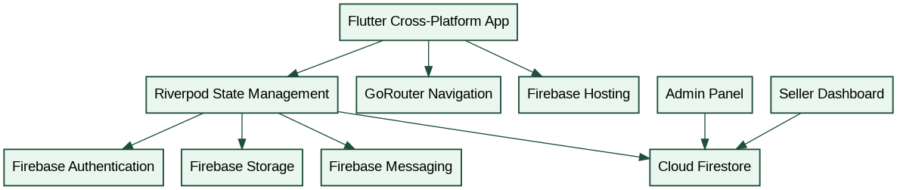
Figure 3.1 - System Architecture Diagram

3.4 Project Structure
olmeg_connect/
|- lib/
| |- core/
| | |- constants/
| | |- errors/
| | |- localization/
| | |- router/
| | |- services/
| | |- theme/
| | |- utils/
| | `- widgets/
| `- features/
| |- admin/
| |- analytics/
| |- auth/
| |- cart/
| |- chat/
| |- home/
| |- notifications/
| |- payments/
| |- posts/
| |- products/
| |- profile/
| |- ratings/
| |- search/
| |- settings/
| `- shell/
|- test/
|- web/
|- android/
|- ios/
|- macos/
|- linux/
|- windows/
|- functions/
|- firebase.json
|- firestore.rules
|- storage.rules
`- pubspec.yaml

3.5 Navigation Structure
- /login
- /register
- /home
- /product/:id
- /cart
- /create-post
- /demo
- /chats
- /chat/:id
- /settings
- /favorites
- /my-products
- /privacy-policy
- /terms
- /edit-profile
- /search
- /advanced-search
- /notifications
- /admin
- /admin/notify
- /admin/moderation
Unauthenticated users are redirected to /login. Authenticated users trying to access /login or /register are redirected to /home. The main shell uses an indexed bottom navigation layout for Home, Feed, Add Product, Chat, Notifications, and Profile.

3.6 Firebase Collections
Collection | Purpose
users | Stores user profiles, email, name, role, admin flag, account type, merchant status, and FCM token.
products | Stores approved product listings.
product_submissions | Stores products waiting for admin moderation.
categories / subcategories | Stores category hierarchy and product grouping.
carts | Stores persisted cart records.
orders | Stores order records, buyer, sellers, items, address, totals, and payment summary.
payments | Stores payment records and payment method/status.
chats | Stores buyer-seller product conversations and messages.
posts | Stores social marketplace posts.
posts/{postId}/comments | Stores comments on posts.
favorites | Stores favorite products.
reviews | Stores product reviews.
ratings | Stores seller/user ratings.
reports | Stores reports against products, sellers, reviews, or posts.
notifications | Stores user notifications.
admin_notifications | Stores admin broadcast and notification records.
merchant_verifications | Stores merchant approval requests.
sellerProfiles | Stores seller profile data.
analytics_events | Stores tracked product/user events.

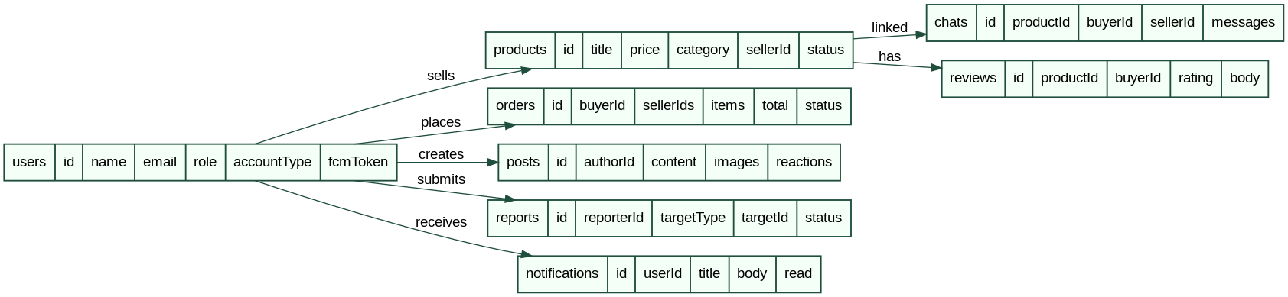
Figure 3.2 - Entity Relationship Diagram
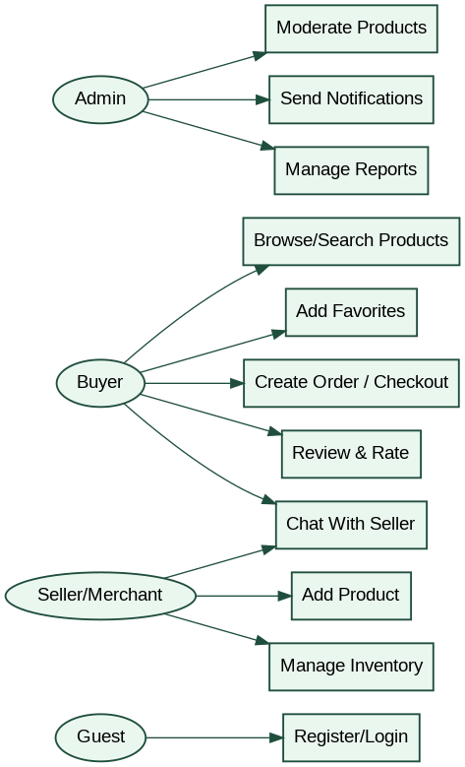
Figure 3.3 - Use Case Diagram

Chapter 4 - Implementation

4.1 Main Application Flow
Application entry starts in lib/main.dart. The startup process ensures Flutter bindings are initialized, initializes Firebase using lib/firebase_options.dart, starts Riverpod ProviderScope, initializes notification services after the first frame, and loads router, theme mode, and locale providers. The router file is lib/core/router/app_router.dart.

4.2 Authentication
The authentication feature includes login, register, Firebase-backed auth state handling, user roles, merchant account type support, and admin detection. The main screens are login_screen.dart and register_screen.dart. The login UI supports English and Arabic, and the register UI supports merchant registration options.

4.3 Products and Marketplace
The products feature includes product listing, product details, add product flow, category filtering, product cards, badges, gallery widgets, seller UI components, favorites, my products, product reviews, ratings, variants, stock, return policy, delivery estimate, and moderation status. Important screens include shop_screen.dart, add_product_screen.dart, product_detail_screen.dart, cart_screen.dart, and home_screen.dart.

4.4 Search
The search feature contains a search screen, advanced search screen, search provider, repository, datasource layers, and filter entity support. The advanced search screenshot shows filters for keyword, category, condition, and price range.

4.5 Cart, Orders, and Payments
The app contains cart screen and cart provider logic. Checkout review and order detail screens support order creation and payment summaries. Payment records are stored in Firestore payments collection using paymentMethod: paypal. The flutter_paypal package exists in the dependencies, but a full visible PayPal checkout UI flow is not complete yet.

4.6 Social Feed and Posts
The social feed includes feed screen, create post screen, post profile screen, product matching utilities, image grid widgets, preview widgets, reaction bar, and enhanced post card widgets. This creates a social-commerce layer where users can share marketplace-related posts and interact with community content.

4.7 Chat
The chat feature includes chat list screen, chat detail screen, chat provider, entity, model, and datasource layers. Chat is linked to products so buyers and sellers can communicate about specific listings. Current chat progress is 80%.

4.8 Notifications
Notifications include a notifications screen, notification provider and repository layers, Firebase Cloud Messaging integration, and foreground/background notification handling service. User FCM tokens are stored in user documents.

4.9 Admin Module
The admin module contains admin dashboard, admin notification screen, product moderation screen, reports management, and merchant verification features. The admin-only profile/access page provides access to Admin Dashboard, Admin Notifications, Product Moderation, Help & Support, account management, and sign out. This page is visible only to admin users and supports role-based UI visibility using the user role/admin flag.

4.10 Ratings, Reviews, Reports, Profile, and Settings
The ratings and reviews modules include rating entity, model, datasource, repository, provider, and rating widget. Reports support reporting products, sellers, reviews, or posts. Profile and settings include edit profile, favorites, privacy policy, terms, app settings, dark mode, and language switching.

4.11 AI Moderation
The moderation service is implemented in product_moderation_service.dart. The current implementation is rule-based local moderation, not an external AI API. It checks title length, description length, price validity, and blocked terms such as weapons, drugs, fake IDs, stolen/counterfeit items, hacking, and explosives. Approved products go directly to products, while rejected or suspicious products go to product_submissions for admin review.
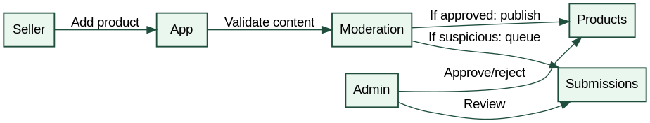
Figure 4.1 - Product Moderation Sequence
Figure 4.2 - Checkout Sequence
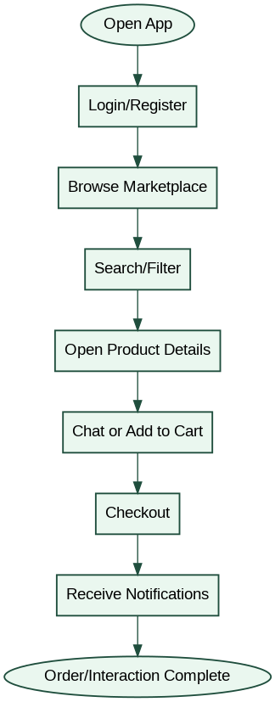
Figure 4.3 - Main User Activity Flow
Figure 4.4 - Class Diagram
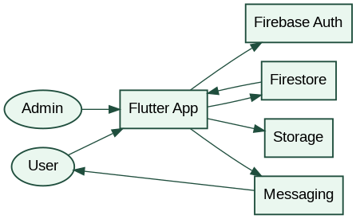
Figure 4.5 - Data Flow Diagram

Chapter 5 - Testing & Evaluation

5.1 Testing Strategy
Testing was conducted through manual testing, widget smoke tests, cart calculation tests, order creation tests, merchant delivery tests, Firebase integration testing, responsive UI testing, localization testing, and navigation testing. The repository includes test files and supporting QA documents such as TESTING_REPORT.md, TEST_REPORT.md, FINAL_TEST_SUMMARY.md, and TESTING_CHECKLIST.md.

5.2 Current Progress
Area | Progress
UI/UX | 90%
Backend | 80%
Payments | 40%
Chat | 80%
AI Moderation | 60%

5.3 Feature Status
Feature | Status / Notes
Authentication | Implemented with Firebase Auth and auth redirects.
Products | Implemented: listing, details, add product, categories, images, favorites.
Search | Implemented with search and advanced search screens.
Notifications | Implemented with Firebase Messaging and notification screen.
Reviews/Ratings | Implemented data layer and UI widgets.
Reports | Implemented for product/seller/review/post reporting.
Orders | Implemented order records, order details, and checkout review logic.
Admin moderation | Implemented admin moderation access and product moderation queue.
Seller dashboard | Implemented/partial seller tools for dashboard, inventory, and orders.
Social feed/posts | Implemented feed, create post, reactions, image posts.
Favorites | Implemented.
Web support | Configured using Firebase Hosting and Flutter web.
Payments | Partial: Firestore records and PayPal package; full visible checkout flow pending.
AI moderation | Partial: rule-based moderation; external AI API planned.

5.4 Challenges and Solutions
Challenge | Solution
Flutter Gradle build failures | Updated dependencies, cleaned cache, and aligned Flutter/Gradle configuration.
Firebase configuration conflicts | Reconfigured FlutterFire setup and Firebase platform files.
Flutter web image decoding issue | Used cached_network_image and fallback handling.
Navigation complexity | Used GoRouter for route protection and nested navigation.
State management scaling | Used Riverpod and feature-specific providers.
Firestore structure growth | Split data into feature-specific collections.
Notification setup issues | Added Firebase Messaging handlers and token storage.
Responsive overflow in product details | Identified in testing; solved using scrollable/adaptive layouts and SafeArea.

Chapter 6 - Results & Discussion
The current version of Olmeg Connect successfully demonstrates a multi-feature marketplace ecosystem. Compared with the initial template version that mentioned only a few screens, the current app includes many more production-level modules: authentication, marketplace browsing, advanced search, add product, product details, chat, notifications, social feed, admin access, settings, profile, localization, and role-based tools.
The screenshots provided show a consistent dark-mode UI, green accent branding, reusable card components, social-commerce integration, Arabic/English support, and a navigation shell structure. The project is stronger than a simple CRUD application because it combines marketplace, social media, chat, moderation, notifications, seller tools, analytics, localization, and admin systems.

6.1 Limitations
- Firebase rules are development-friendly and must be hardened before production.
- Payment integration is partial and requires a complete live checkout flow.
- AI moderation is currently rule-based and should later use an external AI API.
- Cloud Functions folder is configured but no full checked-in source implementation was found in the snapshot.
- Some UI overflow issues were identified and should be fixed before final demo.

Chapter 7 - Conclusion & Future Work
Olmeg Connect successfully demonstrates a scalable smart marketplace system built using Flutter and Firebase. The project combines product trading, social interaction, seller-buyer communication, notifications, moderation, admin tools, localization, and Firebase backend integration inside one application.
Flutter was chosen because it supports cross-platform development from a single codebase and provides responsive UI components. Firebase was selected because it provides ready-to-use authentication, database, storage, messaging, hosting, and future cloud backend capabilities. Riverpod and GoRouter improve scalability and maintainability by separating state and routing logic.
Future improvements include real AI moderation APIs, complete PayPal checkout, stronger security rules, delivery tracking, recommendation machine learning, production analytics, Google Play release, APK distribution, and improved Firebase Cloud Functions.

Appendix A - Application Screenshots
Figure A.1 - Login Screen - English Interface
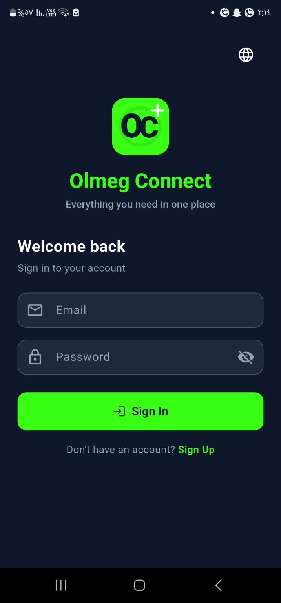
Login Screen - English Interface

Figure A.2 - Login Screen - Arabic Interface

Login Screen - Arabic Interface

Figure A.3 - Register Screen
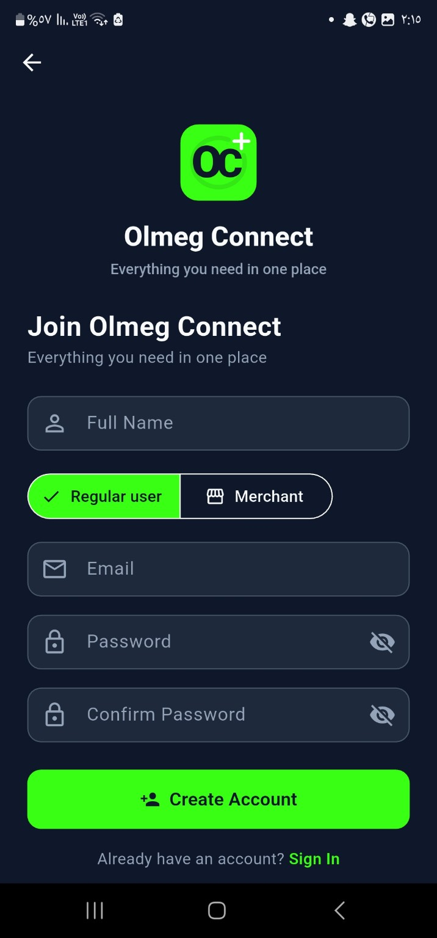
Register Screen

Figure A.4 - Merchant Registration Screen
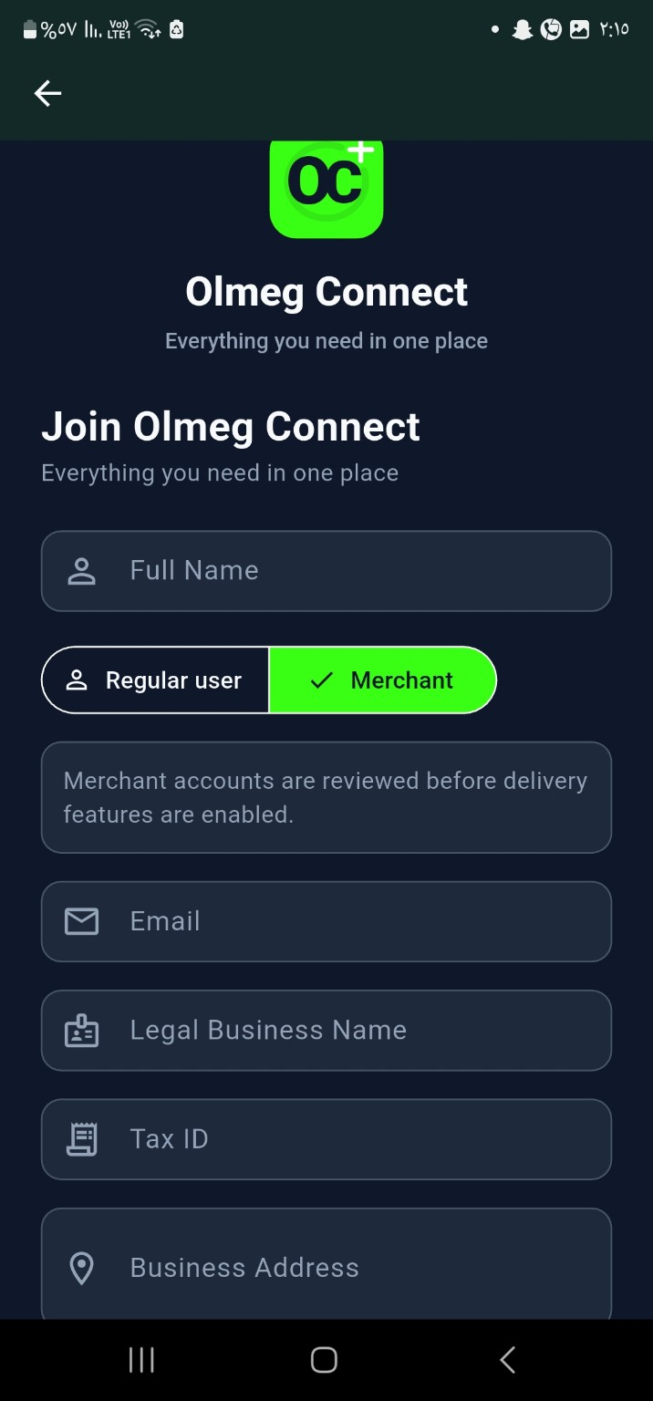
Merchant Registration Screen

Figure A.5 -
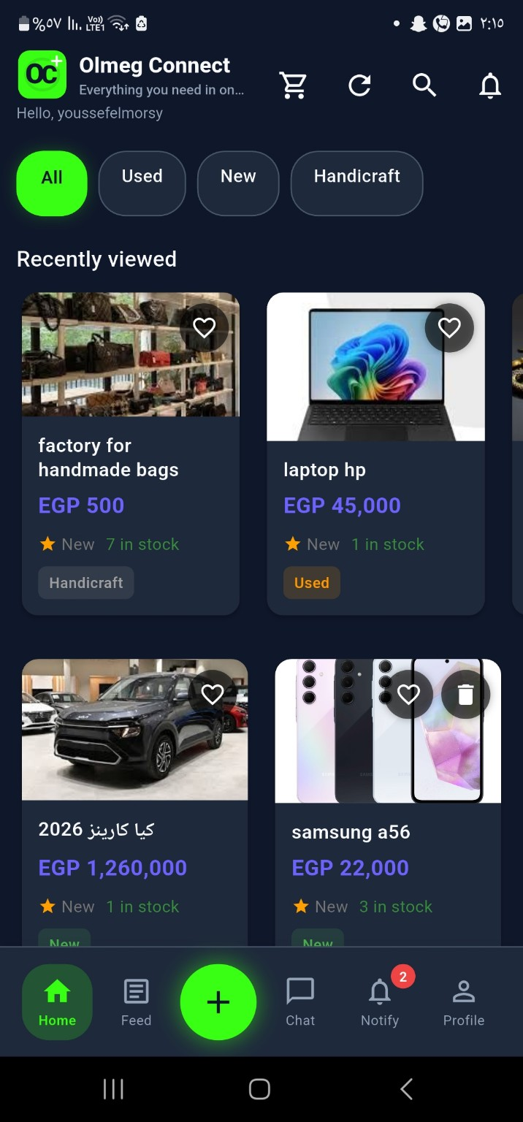
Settings / Profile Related Screen

Figure A.6 - Marketplace / Product Browsing Screen
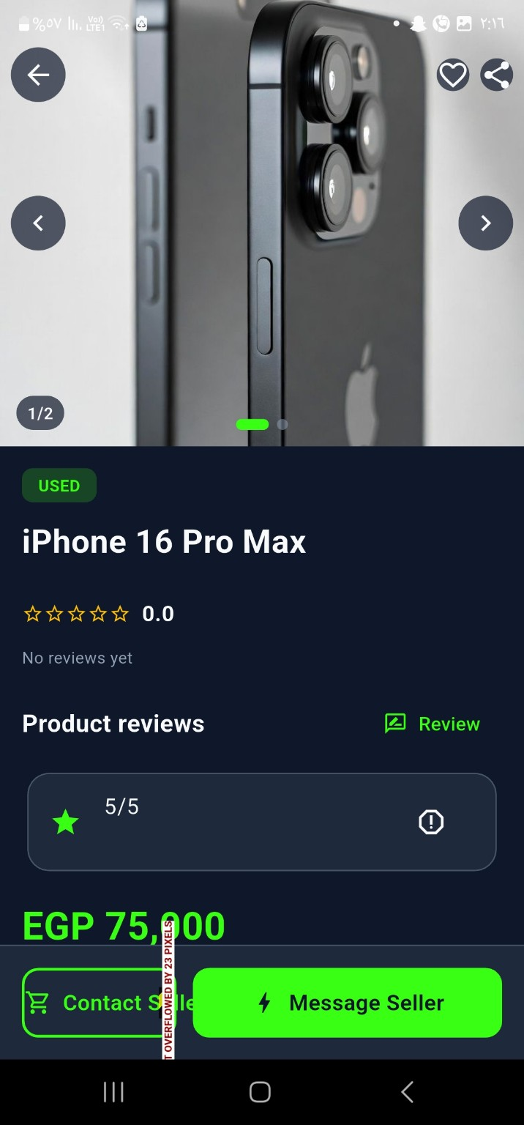
Marketplace / Product Browsing Screen

Figure A.7 - Product Details / Marketplace Interaction Screen
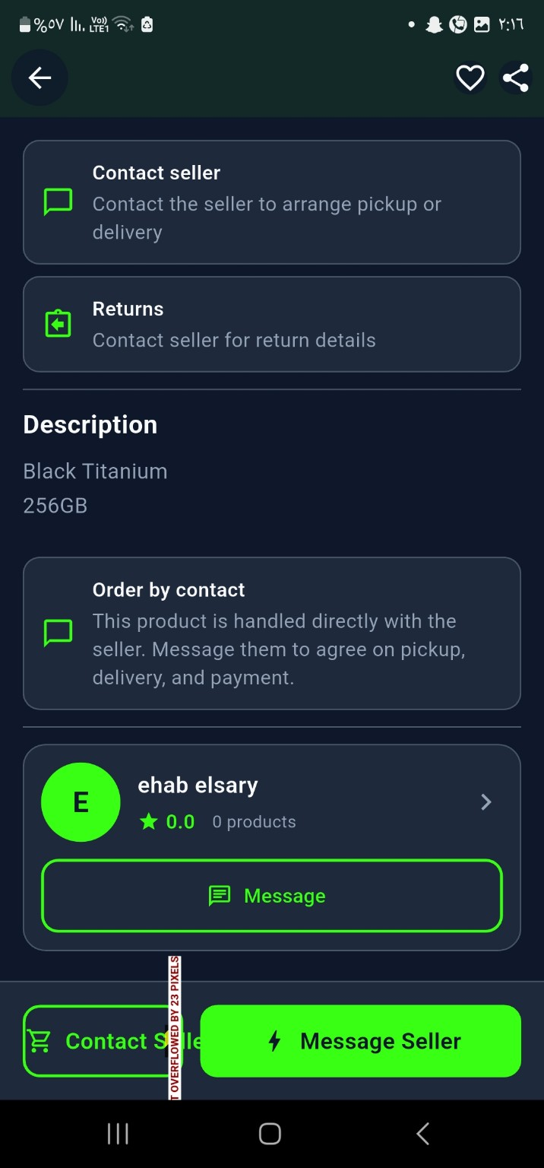
Product Details / Marketplace Interaction Screen

Figure A.8 - Advanced Search / Filter Screen
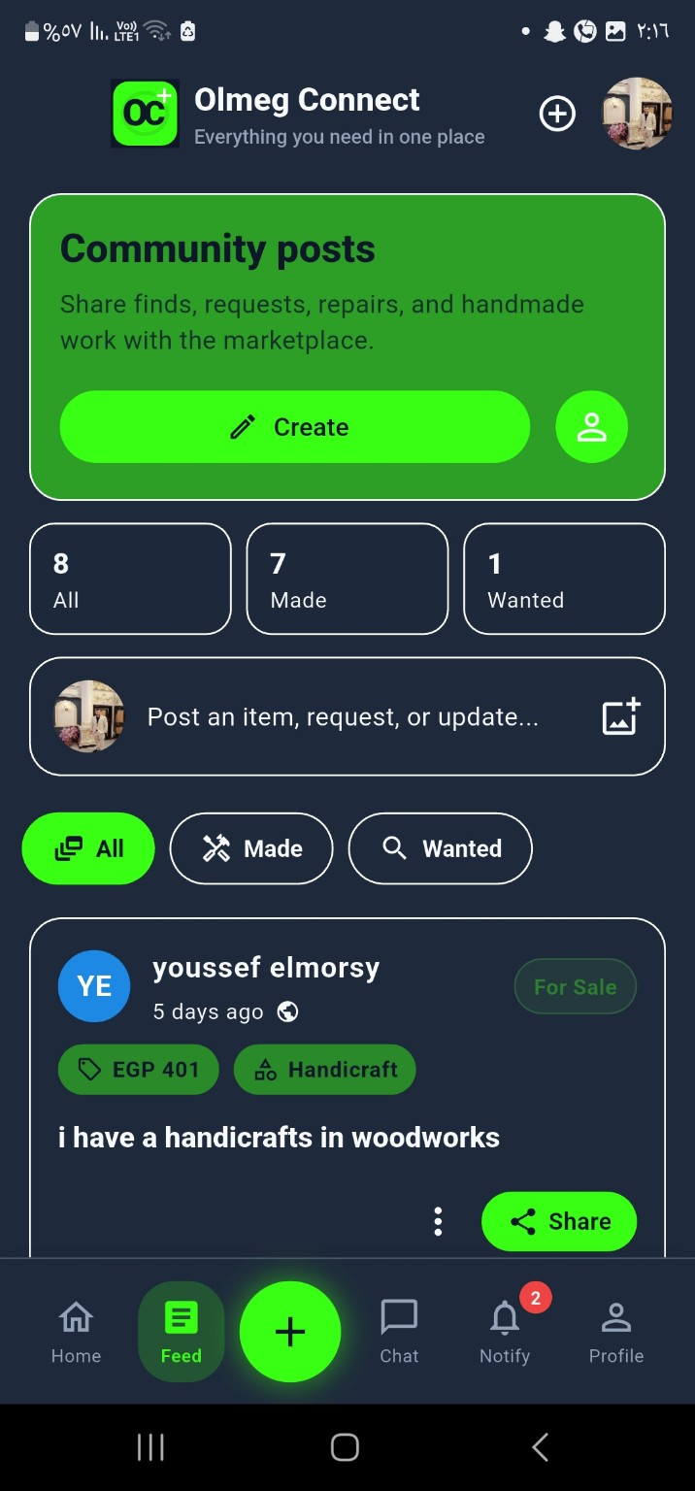
Advanced Search / Filter Screen

Figure A.9 - Notifications Screen
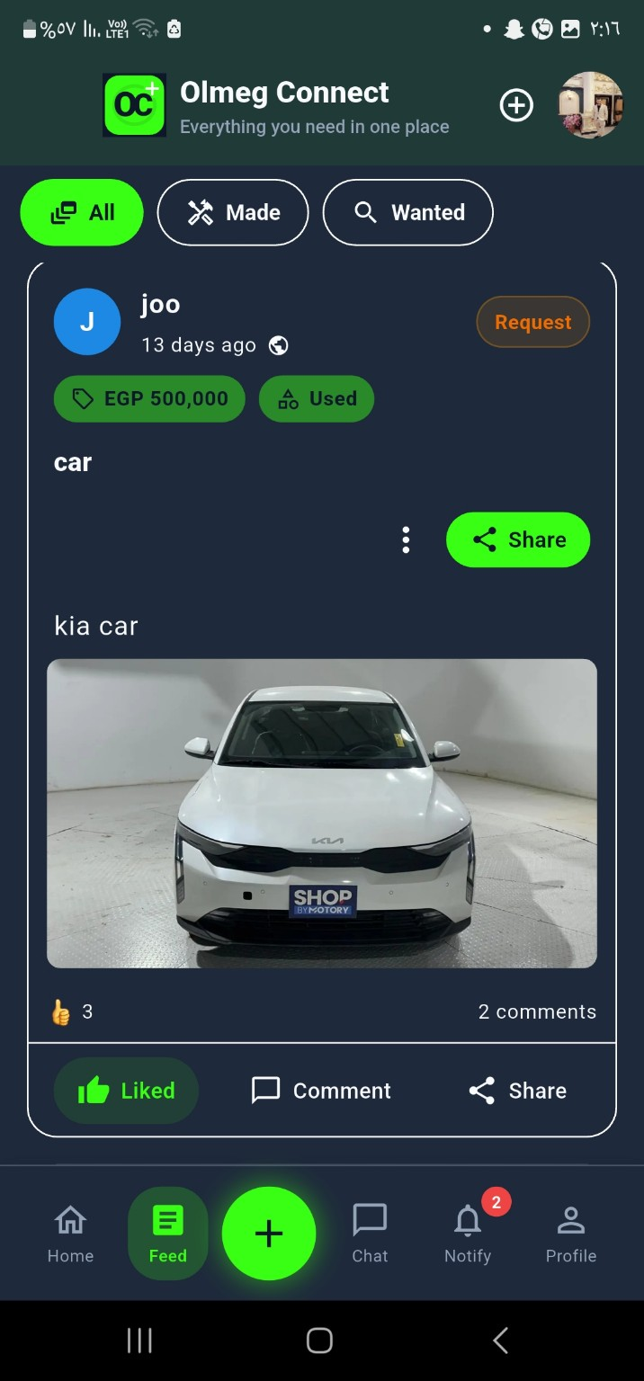
Notifications Screen

Figure A.10 - Profile Screen
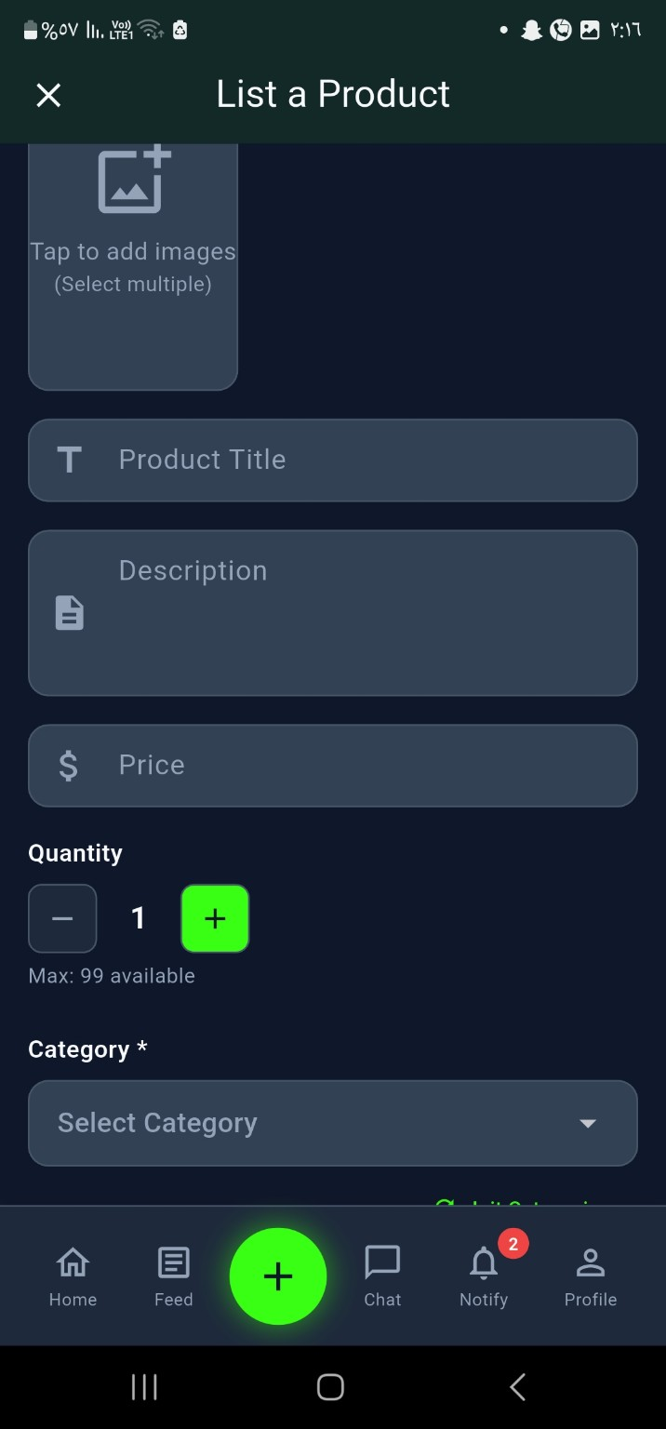
Profile Screen

Figure A.11 - Chat List Screen
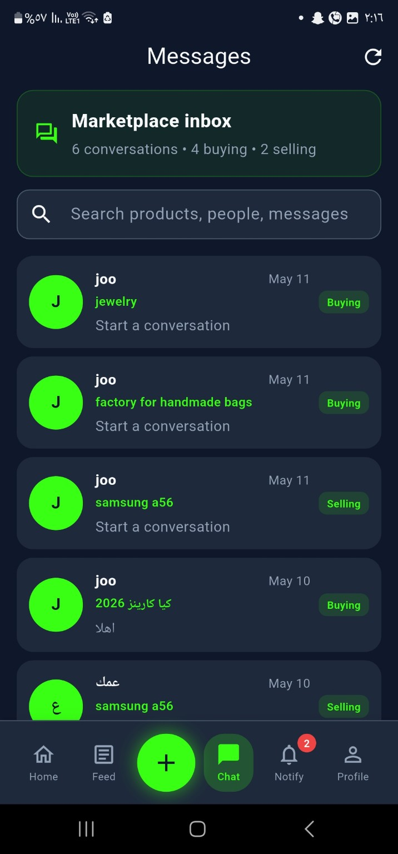
Chat List Screen

Figure A.12 - Chat Details Screen
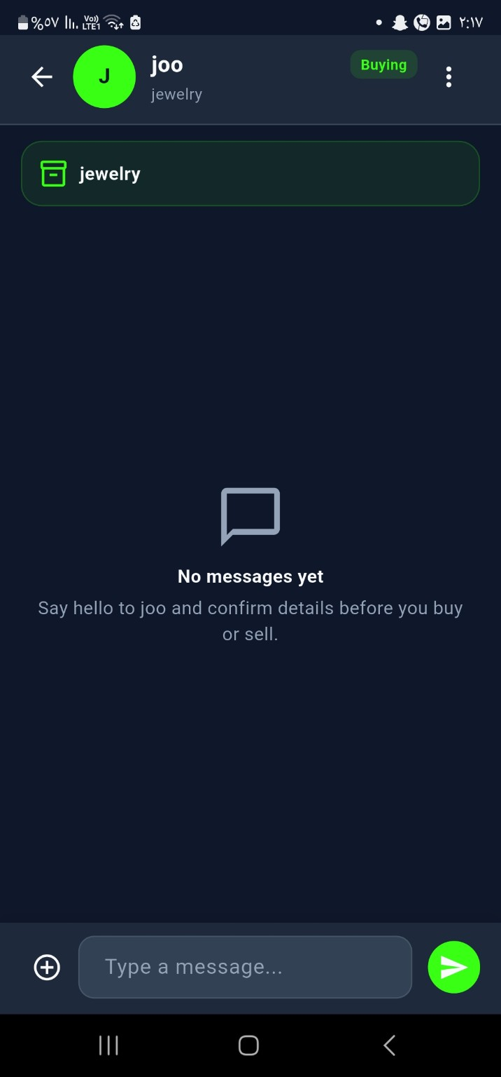
Chat Details Screen

Figure A.13 – notification Screen
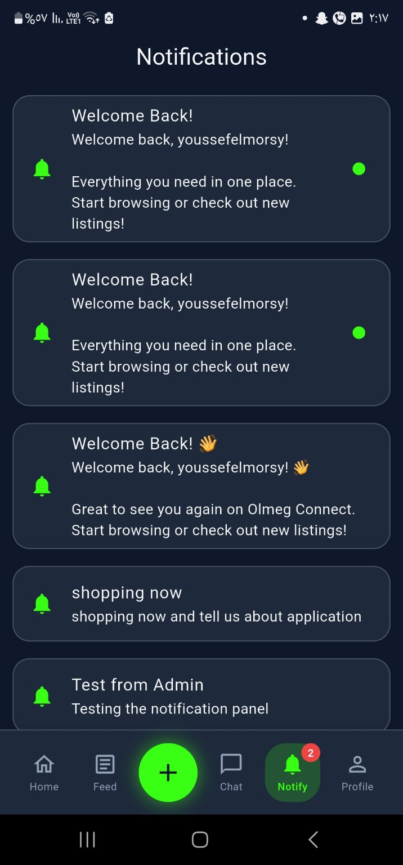
Notification Screen

Figure A.14 - Settings / Profile Related Screen
Settings / Profile Related Screen

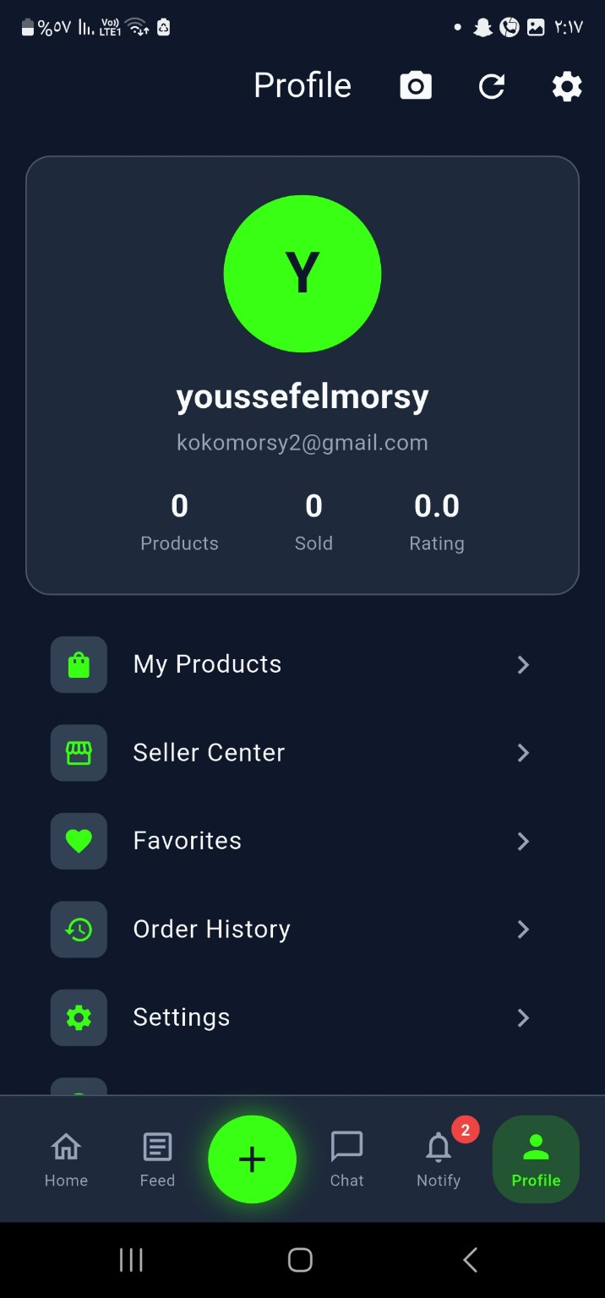
Settings / Profile Related Screen

Figure A.15 - Admin-Only Profile Access Panel
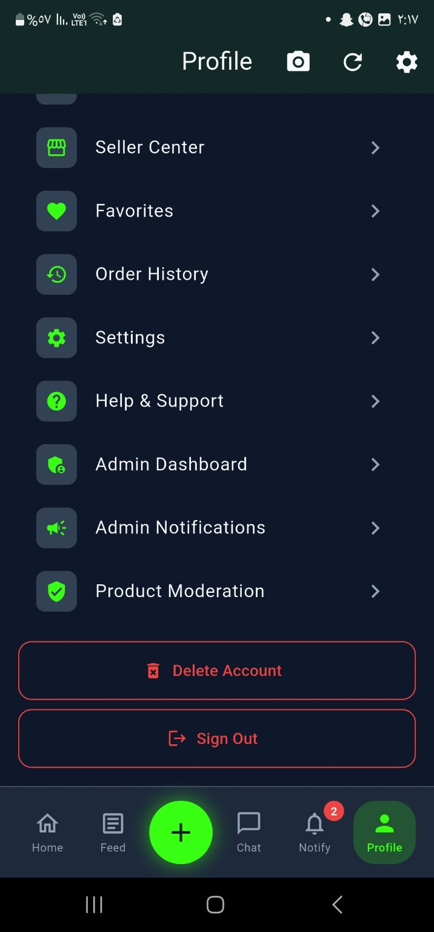
Admin-Only Profile Access Panel

Figure A.16 – advanced search
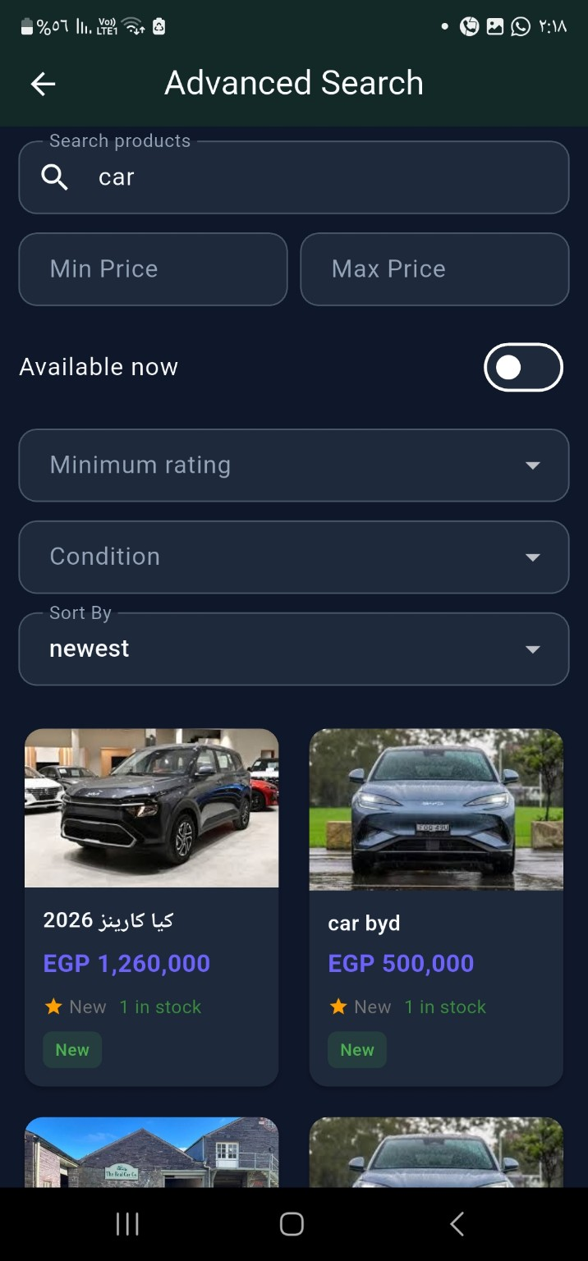
Advanced search

Figure A.17 - Product Details Screen With Responsive Test Observation
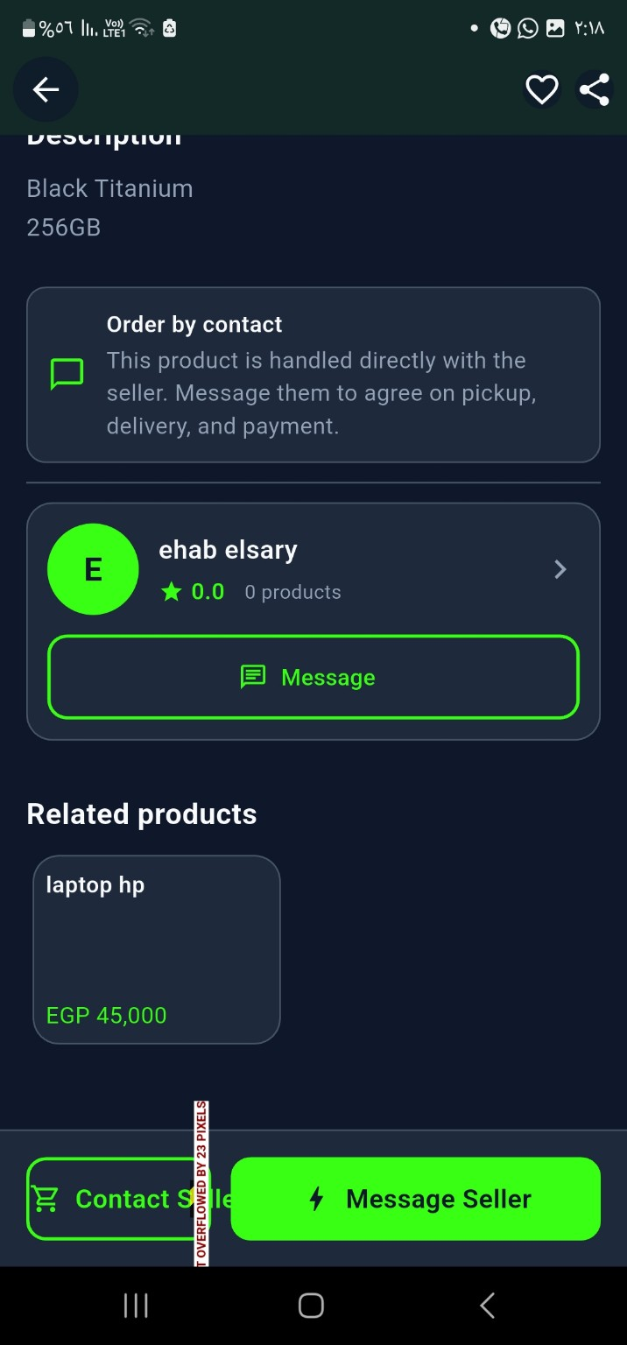
Product Details Screen With Responsive Test Observation

Figure A.18 - login / Account setting Screen
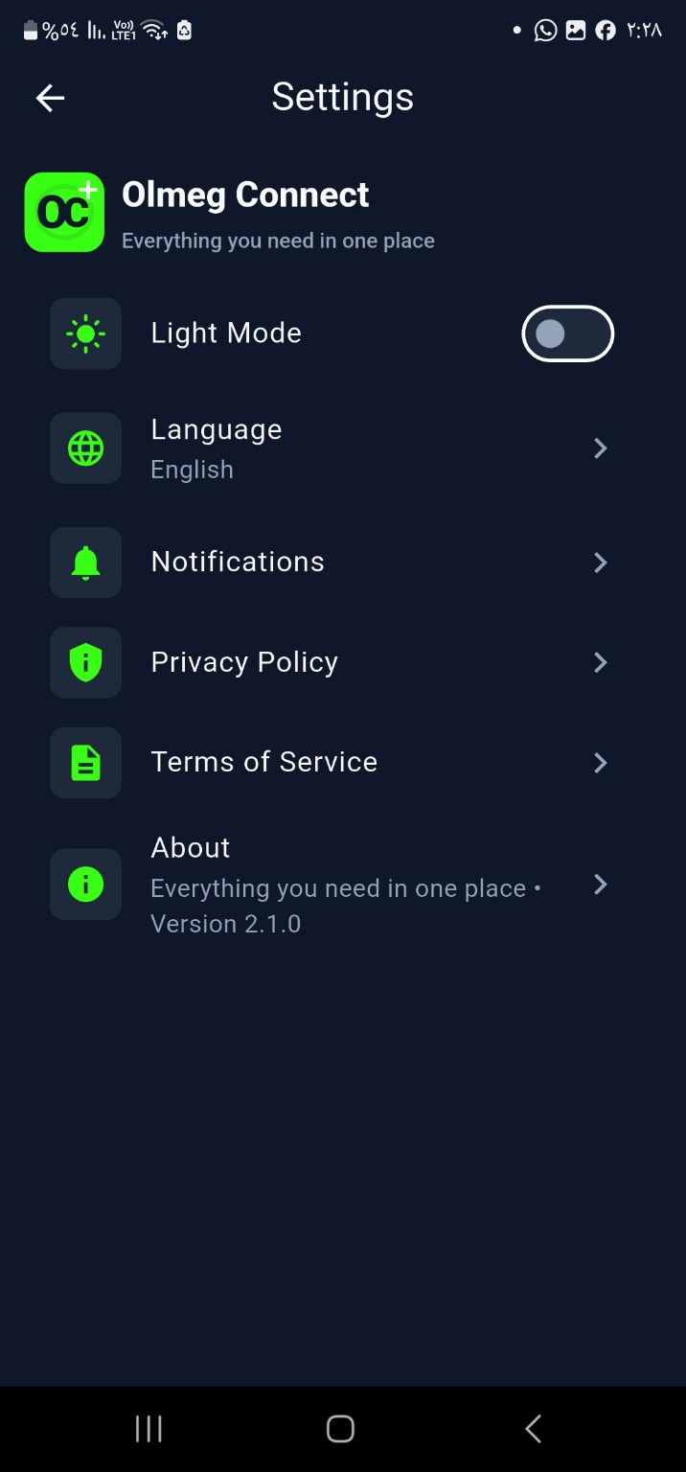
login / Account setting Screen

Appendix B - System Diagrams

System Architecture


Use Case Diagram


ERD


Product Moderation Sequence


Checkout Sequence

Activity Diagra

Class Diagram

Data Flow Diagram


Appendix C - Future Links and Deployment Information
Item | Value
GitHub Repository | https://github.com/Youssef-hafez-elmorsy/OLMEG-Connect
Firebase Project ID | olmeg-connect
Firebase Hosting URL | https://olmeg-connect.web.app
Current App Version from pubspec.yaml | 1.6.1
APK Download Link | https://drive.google.com/drive/folders/1GoLSewKVjy0WXw75xmQXQQanrdasFpgY?usp=drive_link
Figma Design Link | https://www.figma.com/design/cK4LMDMP5rVPOaLzbJVVuY?node-id=23-2
Firebase Authentication Screenshot | 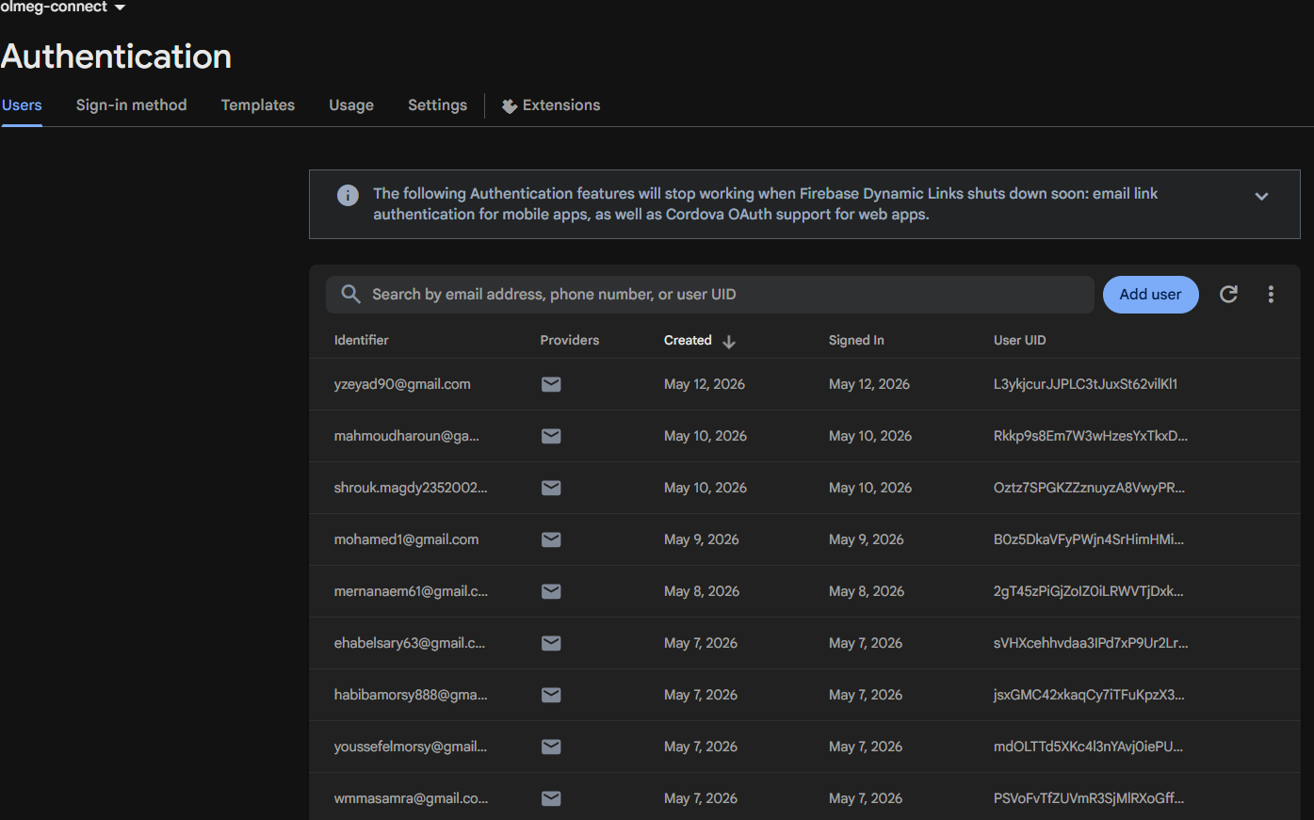
Firestore Collections Screenshot | 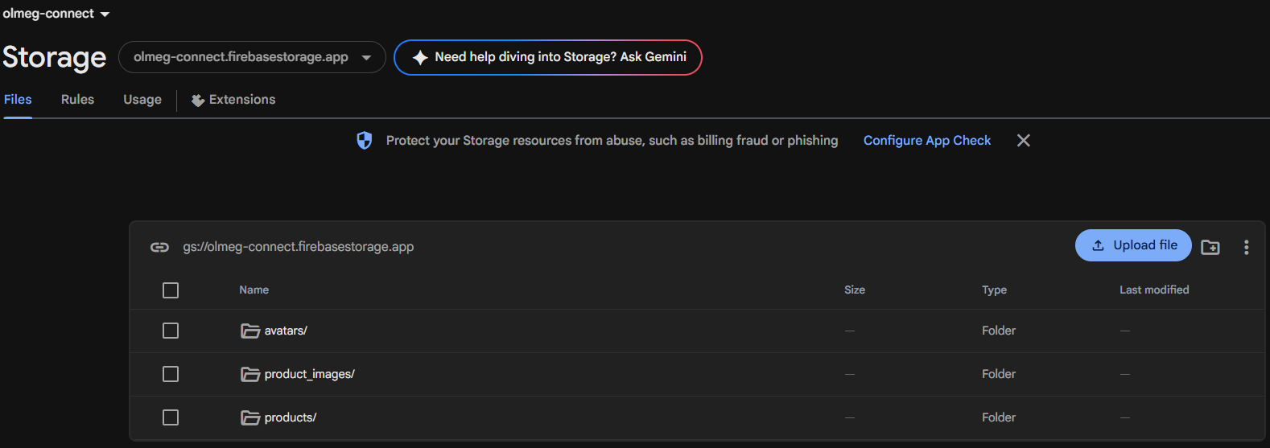
Firebase Messaging Screenshot
Firestore Rules Screenshot | 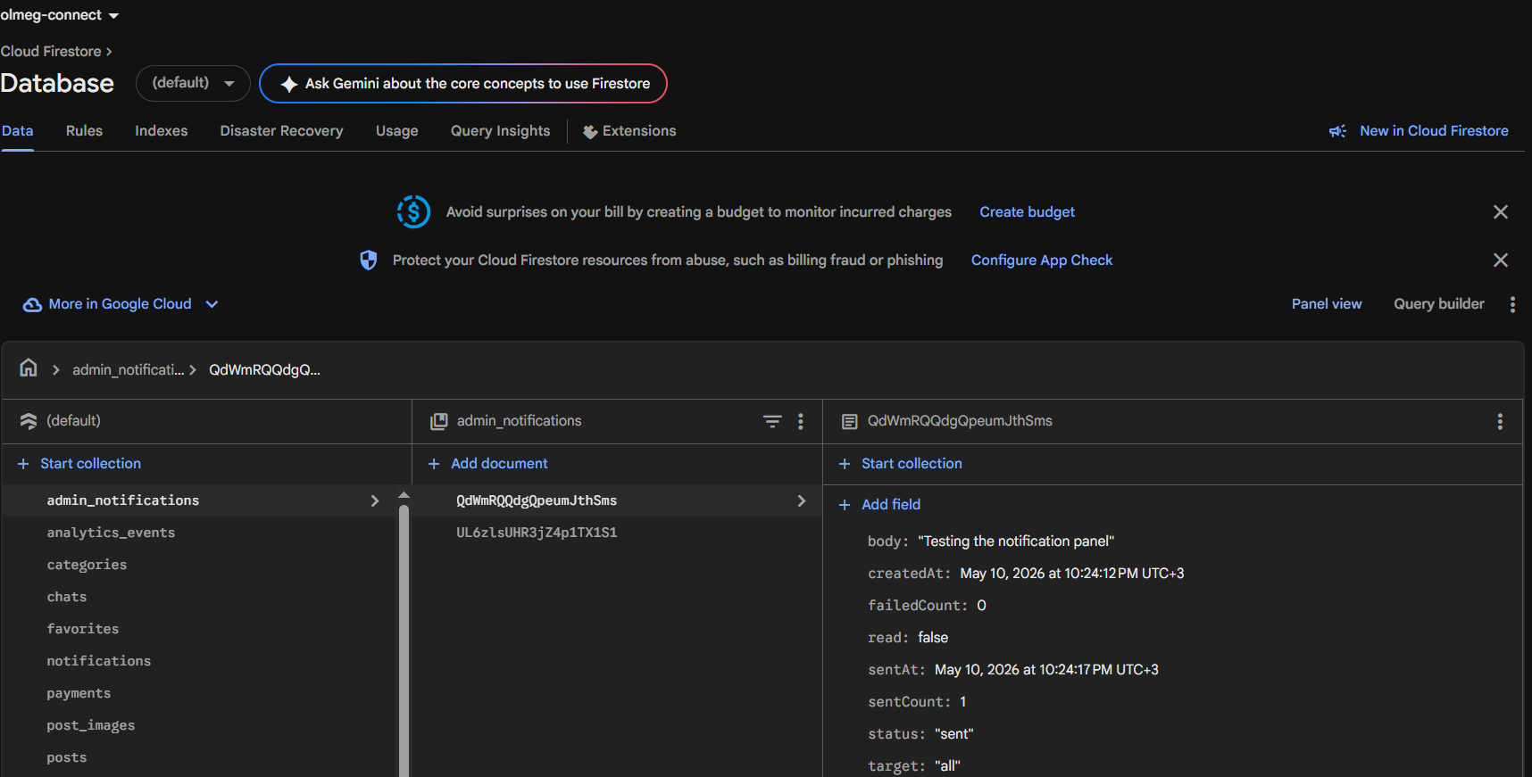

Deployment Commands
flutter pub get
flutter run
flutter test
flutter build apk --release
flutter build web --release
firebase deploy --only hosting --project olmeg-connect
firebase deploy --only firestore,storage,functions

References
Flutter Documentation. Google. https://docs.flutter.dev
Firebase Documentation. Google. https://firebase.google.com/docs
Riverpod Documentation. https://riverpod.dev
GoRouter Package Documentation. https://pub.dev/packages/go_router
Material Design Guidelines. https://m3.material.io
Figma Design Platform. https://www.figma.com
Investopedia. Online Marketplace Definition. https://www.investopedia.com/terms/o/onlinemarketplace.asp

